**NATIONAL ASTHMA RESEARCH PROGRAM  
CAREER DEVELOPMENT: FIRST NATIONS’ APPLICANT GUIDE AND ASSESSMENT CRITERIA**

Contents

General information for Applicants 2

Assessment Process 3

Application Guide 3

Track record (20%) 3

Career impact (50%) 3

Asthma impact (30%) 3

Peer Review Guide 4

Track record (20%) 4

Career impact (50%) 4

Asthma impact (30%) 5

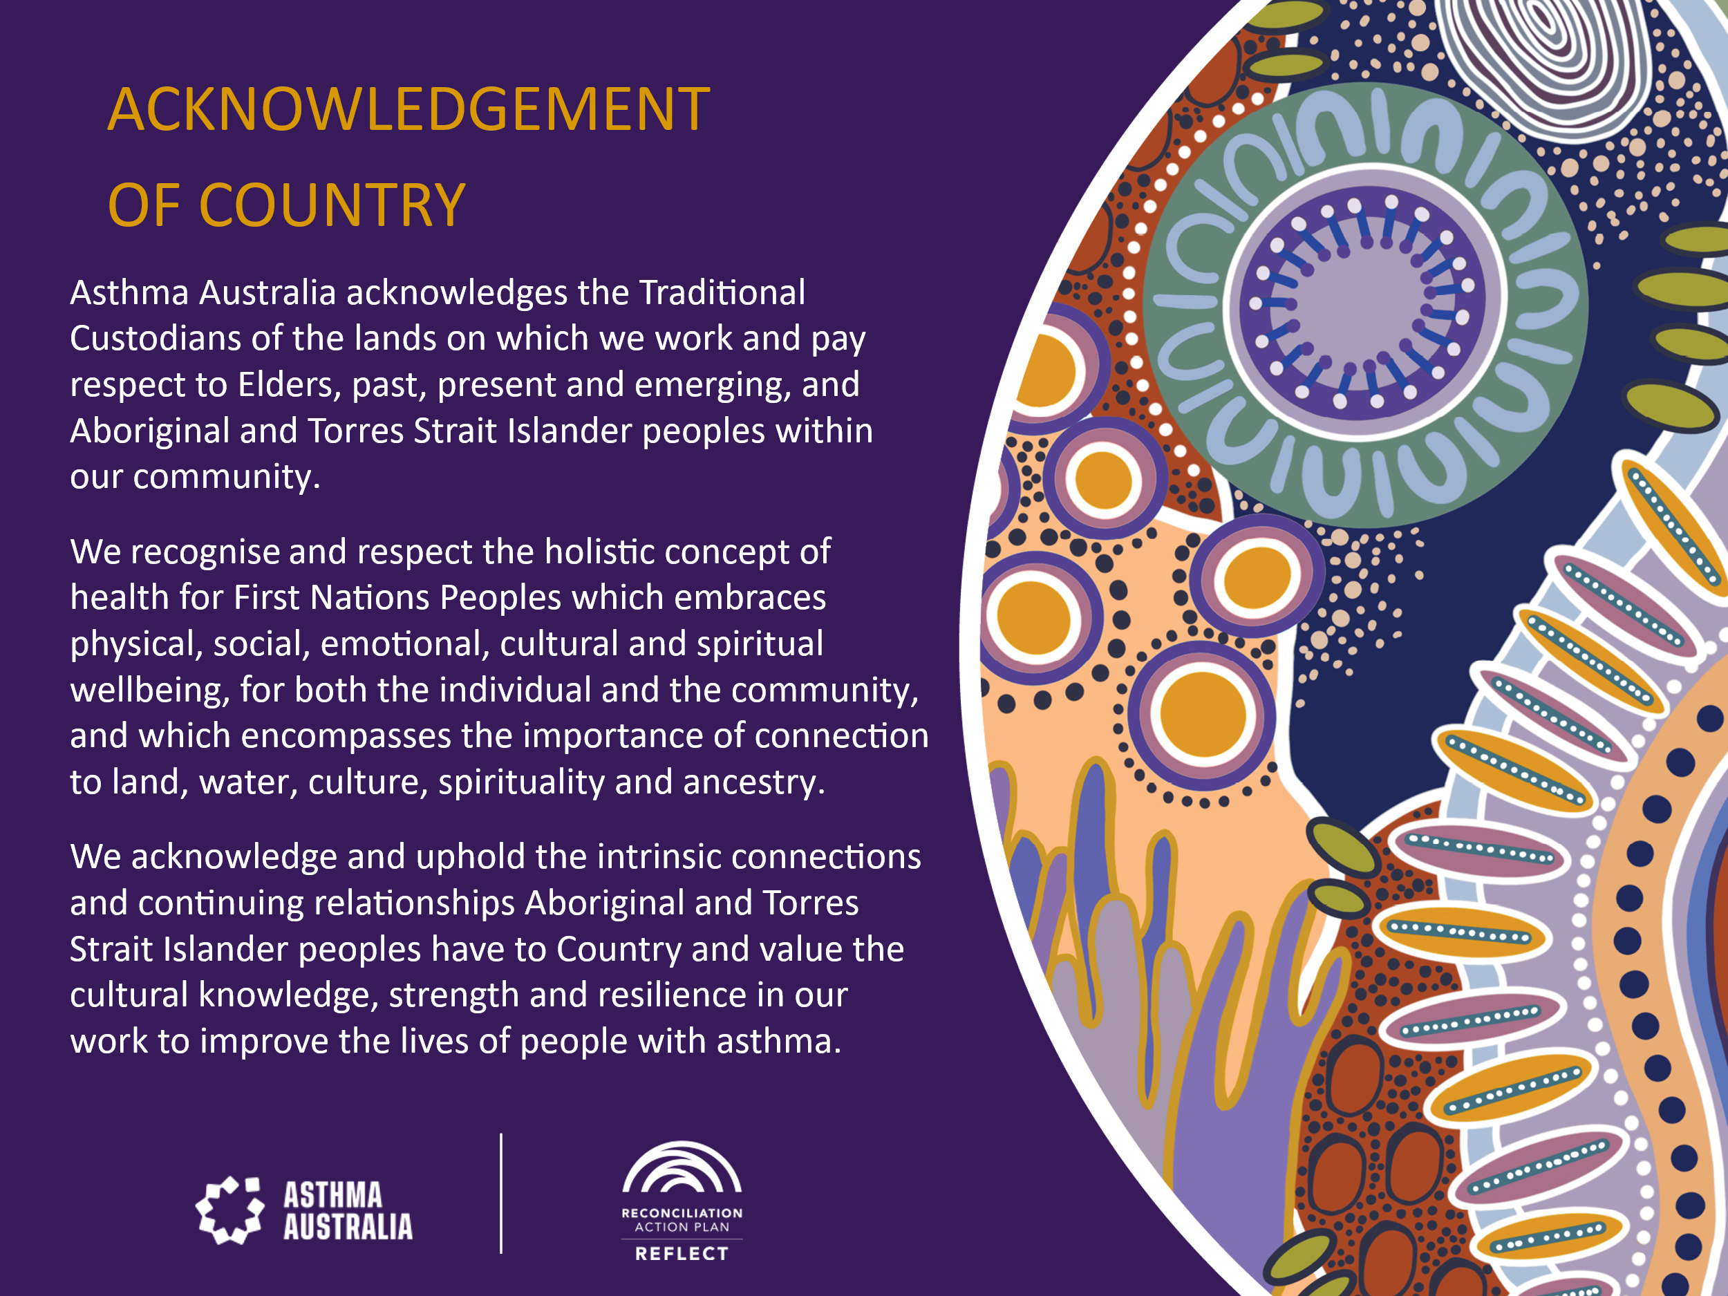

General information

Asthma Australia has a long history of supporting the careers of researchers who have made big contributions to asthma and the lives of people with the condition. We recognise that taking on a research career is a big decision, and it comes with many challenges.

That’s why we have established this grant, aimed towards supporting First Nations higher degree and early mid-career researchers achieve their research goals while strengthening their connection to Country and culture.

First Nations researchers are invited to apply for Asthma Australia’s First Nations Career Development Grant, if the following criteria are met:

* You are a student undertaking a specific academic research program in either an Honours, Masters, or PhD program, or
* You are a post-doctoral fellow within 5 years of completing their PhD
* You are applying for funding that will support their ability to complete their studies, which might include:
  + Travel expenses
  + Cultural events
  + Material expenses
  + Other expenses that support the wellbeing of First Nations’ researchers.

Please refer to the advertisement for other eligibility requirements.

**Submission process**

* Applications should be submitted to [research@asthma.org.au](mailto:research@asthma.org.au). Late or incomplete applications will not be accepted.
* Applications must include
  + Completed application form, including 2-page curriculum vitae
  + Academic transcript
* Consolidate applications in one document. Please avoid sending a transcript separate to an application letter. Application is to be named as follows:
  + SURNAME OF APPLICANT_ FIRSTNATIONSGRANT _YEAR.
* Applications must be lodged electronically in Microsoft Windows Word or PDF format, using the forms provided. Applications not received in this format will not be accepted.
* Files should be no larger than 1mb in size
* Left margin should be at least 2.5cm with content aligned text left
* Font (body) should be Calibri 11 point

**Reporting on progress**

Asthma Australia prioritises developing culturally safe relationships with First Nations’ researchers and their work. To this end we request a report on the work that is completed which was supported by this career development grant.

**Acknowledging Asthma Australia**

We would be grateful if researchers could acknowledge Asthma Australia in their work. This helps spread the message that we are open for business for First Nations’ researchers.

Budget

* The total amount applied for should not exceed $4000
* **Institutional brokerage fees or grant administration levies**   
  Given the size of grants and their source (from charitable donors and supporters), the budget for administrative overheads (institution levies, institutional brokerage, or administration costs) must:
  + Be waived when the grant awarded by Asthma Australia is 100,000 or less,
  + Not exceed 10% of the total project budget when the grant awarded by Asthma Australia is more than $100,000.

Assessing applications

**Eligibility**

The first step for us will be to confirm applicants are indeed working in research. From there we will forward applications on for independent assessment.

All applications are assessed against assessment criteria specific to the First Nations career development grant which are described below.

**Review**Reviewers will assess applications based on the general elements of career experience relative to opportunity, how close the work relates to asthma and how the grant will help the applicant with their career. Further information about these domains is provided in the following pages.

|  |  |
| --- | --- |
| Peer Review Categories | Weight |
| Career experience | 20% |
| Asthma impact | 30% |
| Career impact | 50% |

**Guide for applicants**

The application form must be completed in plain English and be able to be considered by a consumer reviewer. Please provide a simple concise definition of key technical concepts used.

Career experience (20%)

We ask applicants to include their two-page CV in their application which should include awards, outputs and research experience.

We also invite applicants to share information about their personal circumstances, in terms of where the study will take place in relation to Country, and what challenges this might pose.

Asthma impact (30%)

Please explain the connection of the research to the experiences or context of people with asthma. It is not compulsory to have a First Nations focus for the research.

Career impact (50%)

Here we want the applicant to tell us how the grant will help their career goals. This might include reference to mid- and longer-term career goals and may include aspirations and ideas.

Review Guide

Peer reviewers are asked to assess applications on the extent to which they address the criteria below and the domains described on the following pages.

|  |  |
| --- | --- |
| Peer Review Categories | Weight |
| Career experience | 20% |
| Asthma impact | 30% |
| Career impact | 50% |

Career experience

|  |  |
| --- | --- |
| Academic record and research achievement (relative to opportunity), signified by 2 page CV, including examples such as: | |
| * Academic performance: high distinction * Awarded university medal or top of year award * Received more than one university prize/award OR non-university prizes * Has been a lead author on at least two research publications in a peer reviewed journal or book chapter * Has presented at more than three conferences or presentations * Previous full-time research including current studies, or professional experiences * Demonstrates strong community engagement activities | Outstanding (10-9) |
| * Academic performance: distinction * Received at least one university prize OR non-university prize * Has been a lead author on one research publication in a peer reviewed journal or book chapter * Has presented at two or more conferences or presentations * Research project during training (including electives or volunteer work) * Demonstrates some community engagement activities | Very good (8-6) |
| * Academic performance: credit * Received one university prize OR non-university prize * Has contributed to more than one research publication or book chapter * Has presented at one conference * Demonstrates little industry relevant experience | Satisfactory (5-3) |
| * Academic performance: pass or lower * Did not receive any awards or prizes (university or otherwise) * Has not contributed to any research publications or book chapters * Has not presented at a conference | Poor/limited (2-1) |

Career impact (50%)

|  |  |
| --- | --- |
| Career impact | |
| The career development activities will **significantly** enhance the applicant’s career in asthma research | Outstanding (10-9) |
| The career development activities will **somewhat** enhance the applicant’s career in asthma research | Very good (8-6) |
| The career development activities **may** enhance the applicant’s career | Satisfactory (5-3) |
| The career development activities are **unlikely** to enhance the applicant’s career OR are **not related** at all to asthma research | Poor/limited (2-1) |

Asthma impact (30%)

|  |  |
| --- | --- |
| Asthma impact | |
| The applicant’s work is **highly likely** to contribute significantly to asthma knowledge and translatable outcomes for consumers | Outstanding (10-9) |
| The applicant’s work is **likely** to contribute significantly to asthma knowledge and translatable outcomes for consumers | Very good (8-6) |
| The applicant’s work **may** to contribute to asthma knowledge and translatable outcomes for consumers | Satisfactory (5-3) |
| It is **very unlikely** the applicants current work will contribute new asthma knowledge and translatable outcomes for consumers | Poor/limited (2-1) |